 **SIMATS SCHOOL OF ENGINEERING**

**SAVEETHA INSTITUTE OF MEDICAL AND TECHNICAL SCIENCES**

**CHENNAI-602105**

**HOTEL ROOM BOOKING SYSTEM**

**A CAPSTONE PROJECT REPORT**

**Submitted by**

**<R MAMATAH> (192211454)**

**<V VINEELA> (192211465)**

**Under the Supervision of**

**VIVEK BALAJI**

**September 2024**

**DECLARATION**

We, **R Mamatha, V Vineela,** students of **Bachelor of Engineering in Information Technology**, Department of Computer Science and Engineering, Saveetha Institute of Medical and Technical Sciences, Saveetha University, Chennai, hereby declare that the work presented in this Capstone Project Work entitled **Automated Network Security Testing Tools** is the outcome of our own Bonafede work and is correct to the best of our knowledge and this work has been undertaken taking care of Engineering Ethics.

(**R Mamatha** 192211454)

(**V Vineela** 192211465)

Date: 24-09-2024

Place: Chennai

**ABSTRACT:**

The Hotel Booking Management System has been designed to override the problem of existing manual system. This web application is supported to eliminate and, in some case, reduce the hardship faced by manual system. The application is reduced as much as possible to avoid errors while entering the data. It’s also provided message while entering invalid data. No formal knowledge is required for the user to operate this system. Overall, we said that Hotel Booking Management System is user friendly.

**INTRODUCTION:**

Creating a hotel room booking system using HTML, PHP, and a database is an essential project that combines front-end and back-end technologies to provide a seamless experience for users. The HTML component is responsible for creating an intuitive and user-friendly interface, where users can easily navigate to search for available rooms, select their desired check-in and check-out dates, and specify the number of guests. The form elements in HTML ensure that the user inputs are collected efficiently and are ready to be processed by the server.

On the server side, PHP scripts handle the processing of user inputs. When a user submits a booking request, PHP scripts interact with the database to check the availability of rooms for the specified dates. If rooms are available, the booking details are stored in the database, and a confirmation is sent to the user. PHP also manages other functionalities, such as user authentication, session management, and handling errors gracefully. This dynamic interaction ensures that the website remains responsive and provides real-time updates to users, enhancing their booking experience.

The database is a critical component of the hotel booking system, as it stores all the essential data related to room availability, bookings, and user information. By using a relational database like MySQL, the system can efficiently handle multiple queries simultaneously, ensuring data integrity and consistency. The database structure typically includes tables for rooms, bookings, users, and transactions, with relationships defined between them to maintain a coherent data model. This setup allows for efficient data retrieval and manipulation, enabling the system to scale and handle many bookings and users effortlessly. Integrating HTML, PHP, and a robust database creates a comprehensive hotel room booking system that is both functional and user centric.

* **FORMS CREATED:**

1.home.html

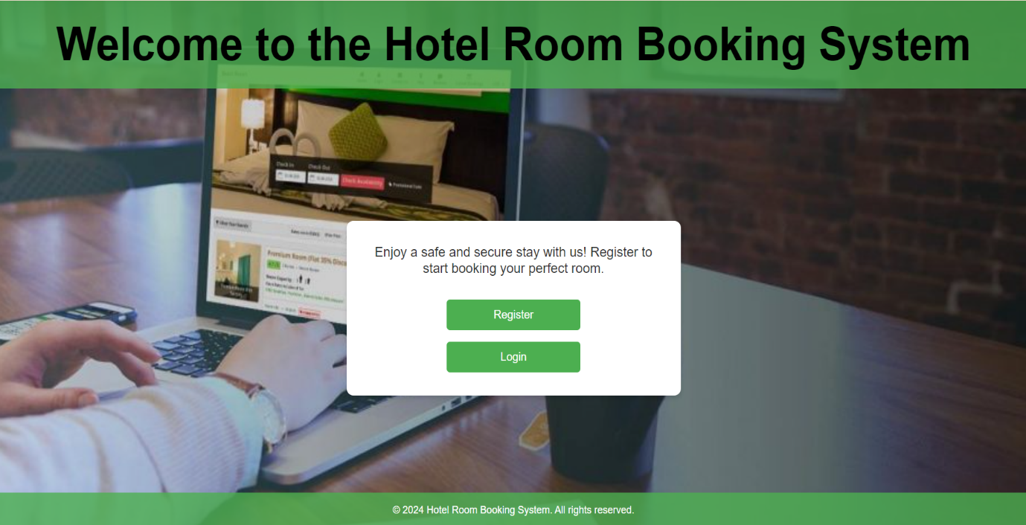

2.register.html

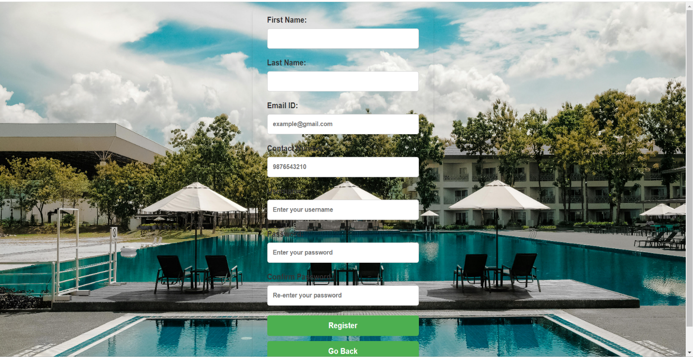

3.success.html

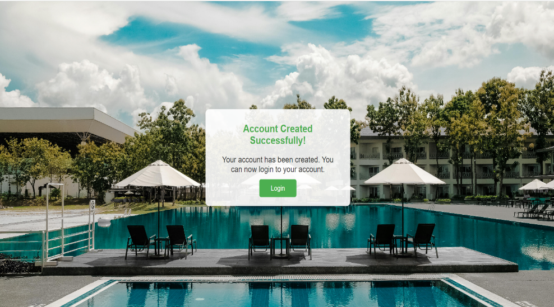

4.login.html

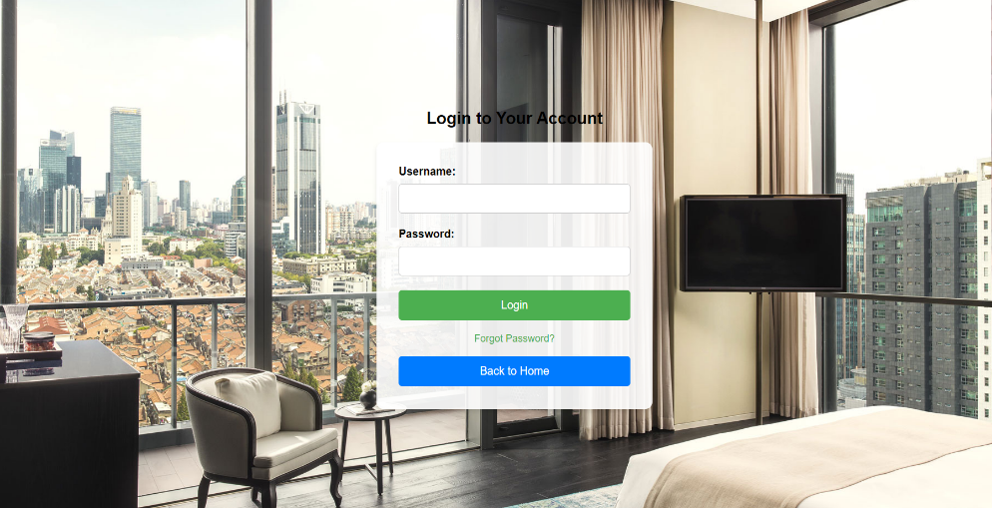

5.forgot.html



6.Select.html

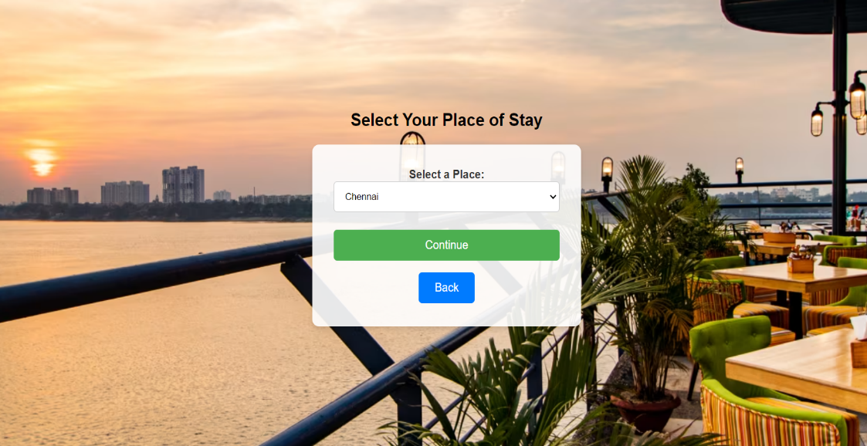

7.hotel.html

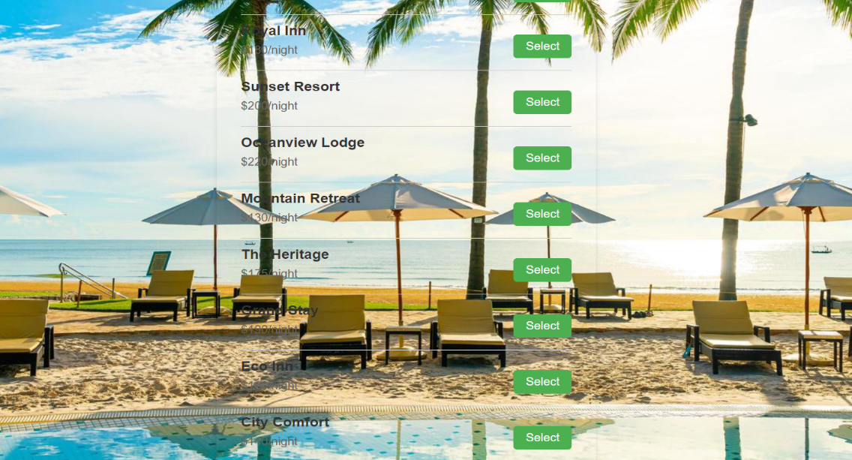

8.booking.html

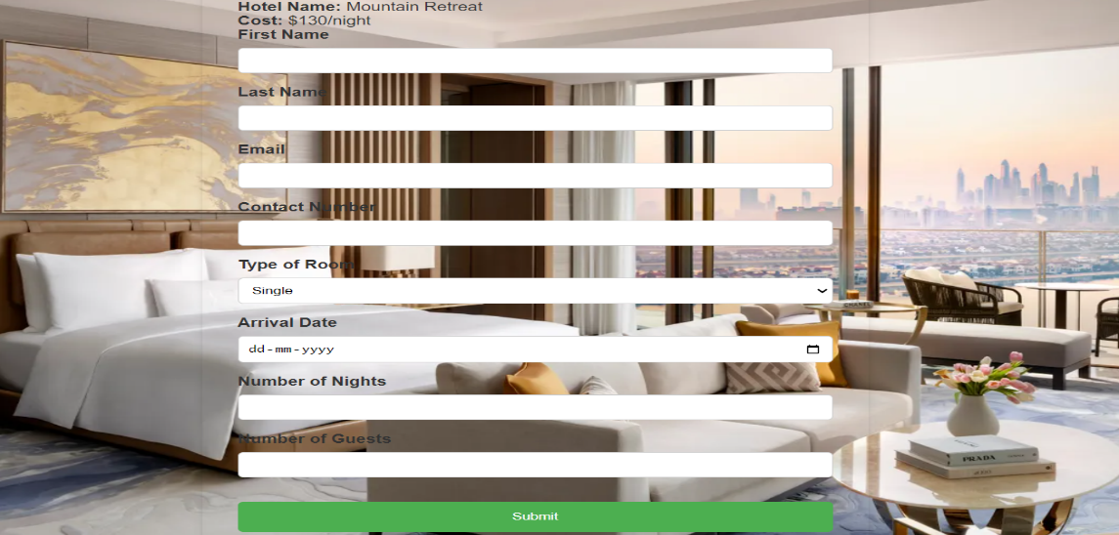

9.payment.html

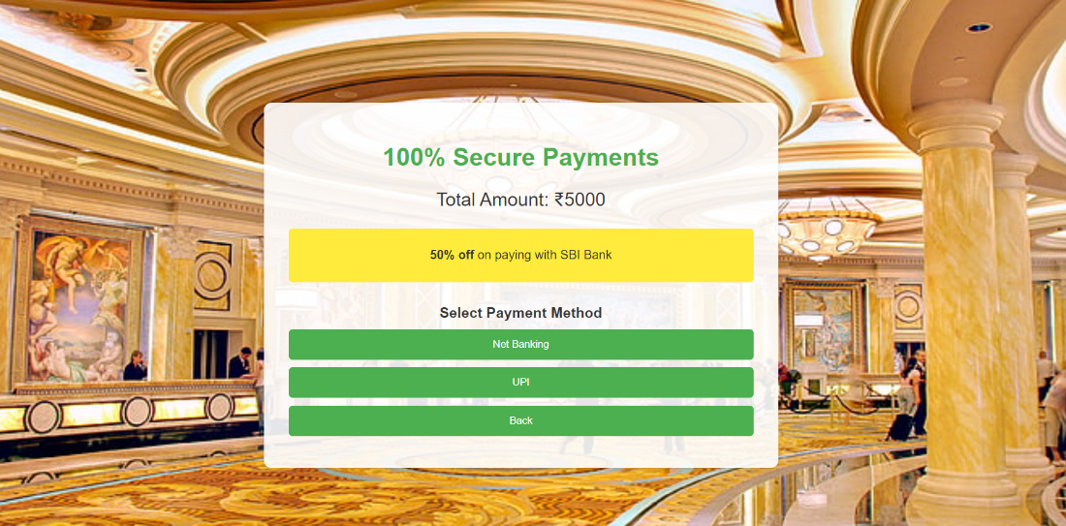

10.bank.html

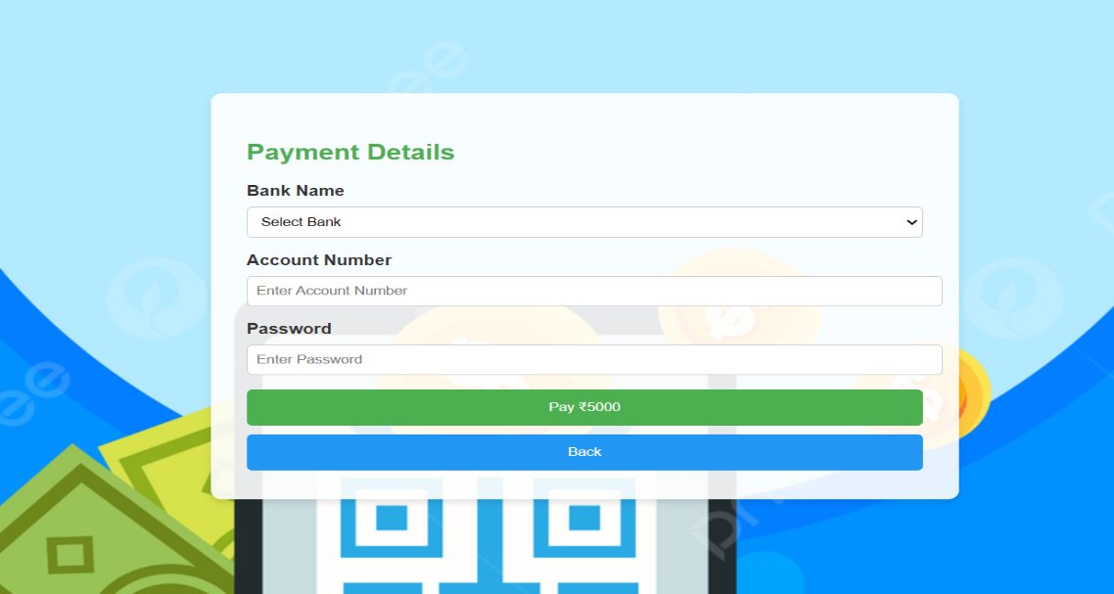

11.paymentsuccess.html



12.cancel.html

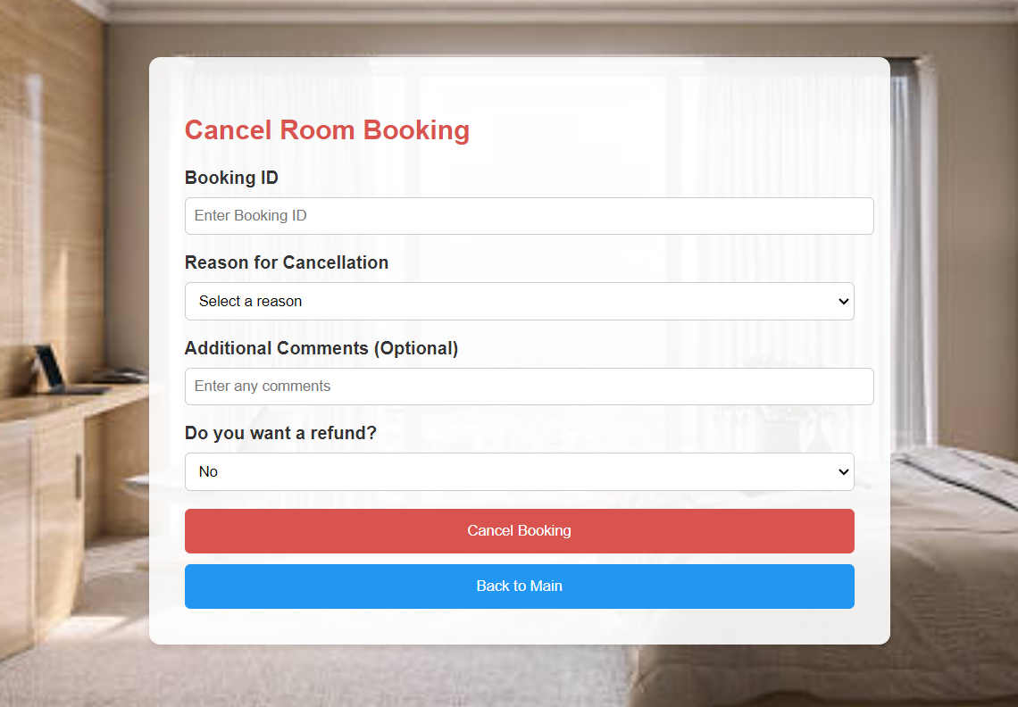

13.cancelsuccess.html

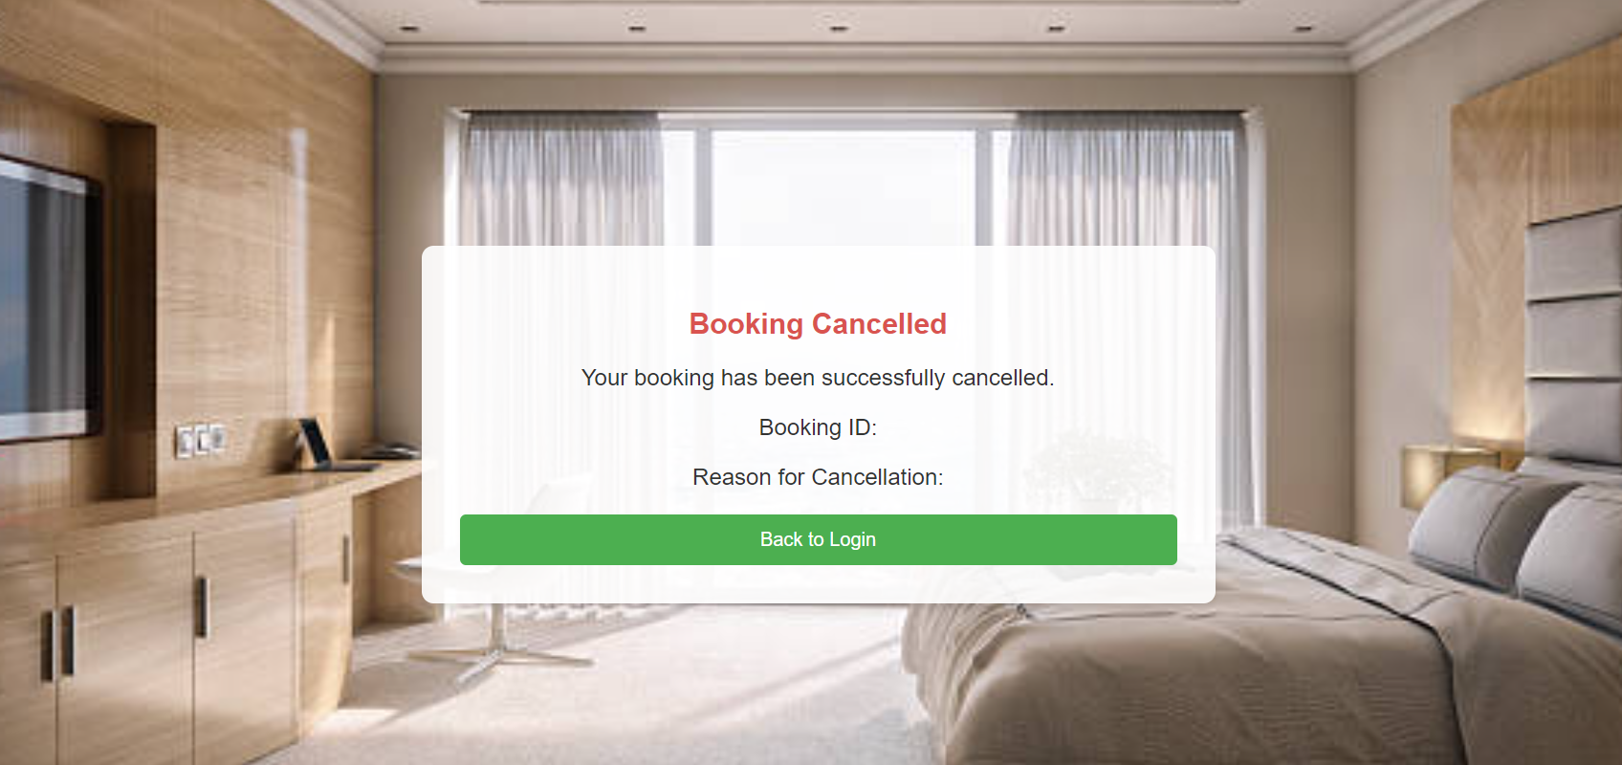

* **CONCLUSION:**

Designing a hotel room booking system integrating HTML and MySQL offers a robust solution for managing reservations efficiently. By leveraging HTML for user interface design and MySQL for database management, this system ensures seamless interaction between customers and hotel administrators. Customers can easily browse available rooms, select desired dates, and confirm bookings through a user-friendly interface. On the backend, MySQL stores and organizes reservation data securely, enabling quick retrieval and updates. Overall, this integrated approach enhances user experience, streamlines booking processes, and optimizes operational efficiency for hotel management.